1.
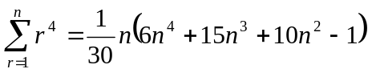

2.
Prove by mathematical induction.

3.
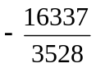

4.
(i) 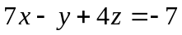
(ii) and meet at 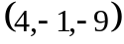
(iii) 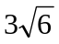

5.
(i) 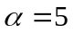 , 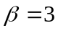
(ii) 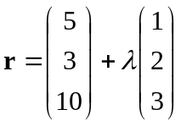
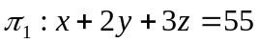 , 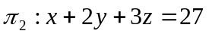

6.
(i) 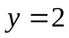 ,  , 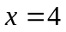
(ii) Local maximum point : 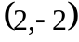 , local minimum point : 